Name: Zeenat Class: TYIT Roll no: 578

Practical 5

Google colab link: <https://colab.research.google.com/drive/1kx2fQ-NvedFtb05ITteRVziiPhTm8OGM#scrollTo=cpb_f_2SDYCt&line=3&uniqifier=1>

Aim: Bayesian Classifier heart.csv dataset

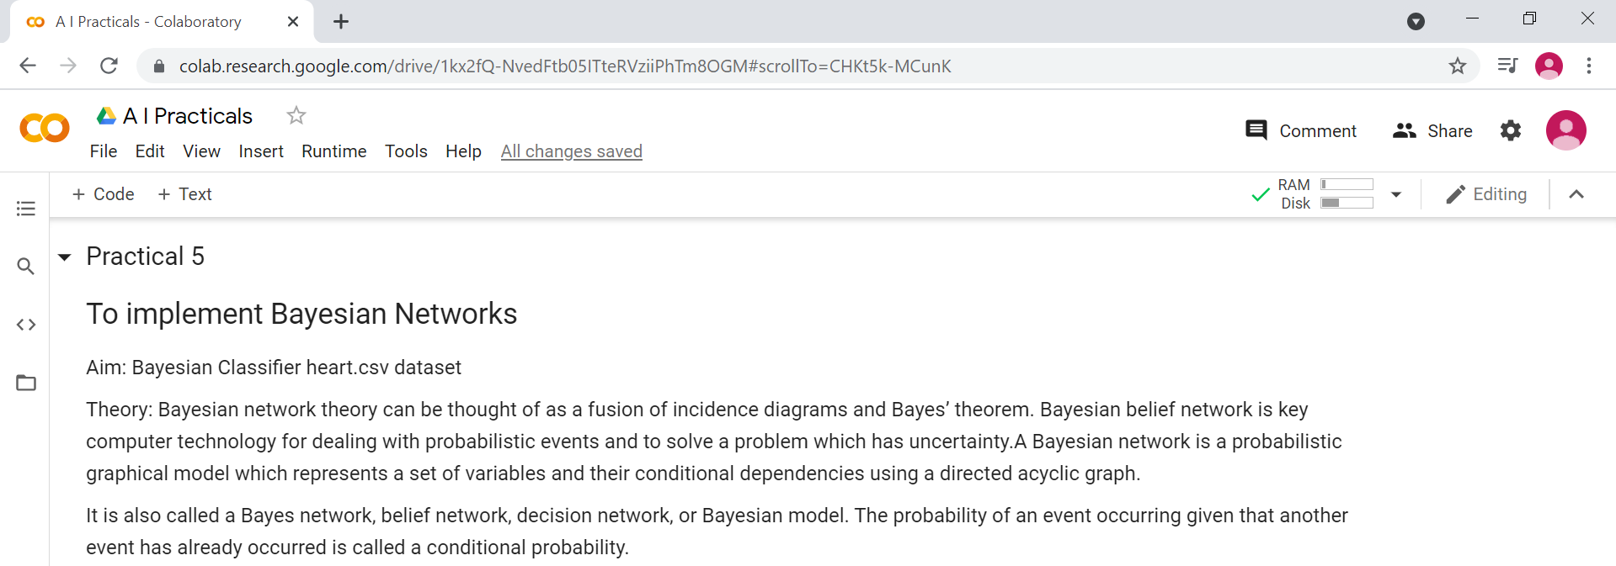

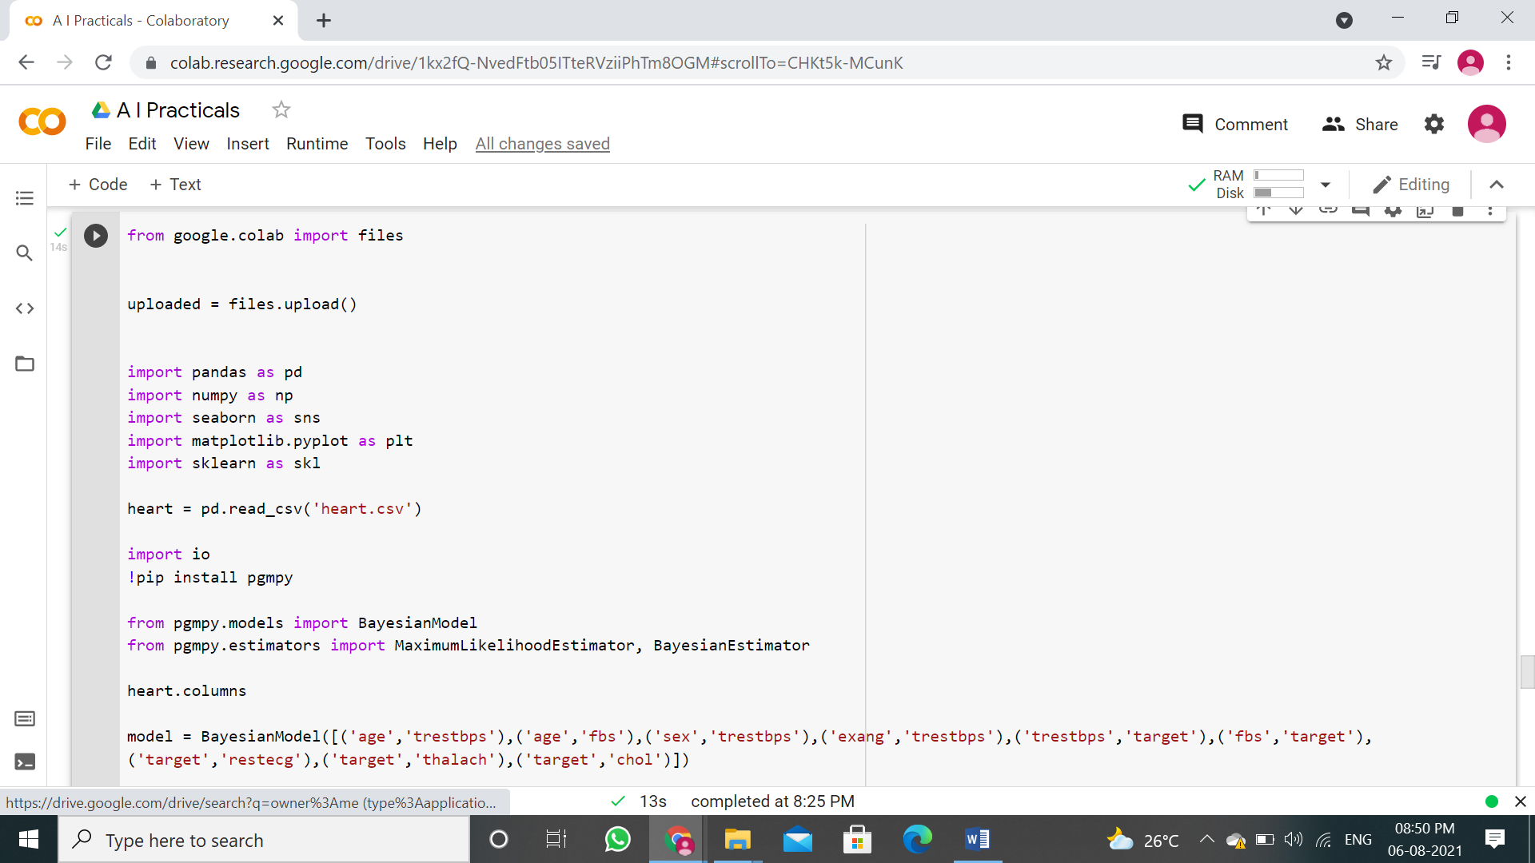

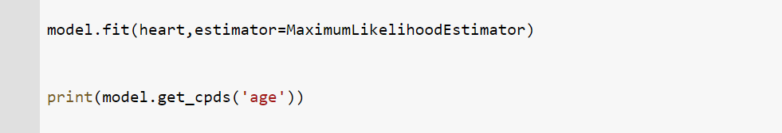

Output:

